 | COMPANY & CAPABILITIES

COMMERCIAL + RESIDENTIAL CONSTRUCTION

Construction with clarity.
Palmyra Projects brings construction, estimating and commercial management together. Clear decisions, coordinated delivery and attention to detail guide our work from the first conversation to handover.
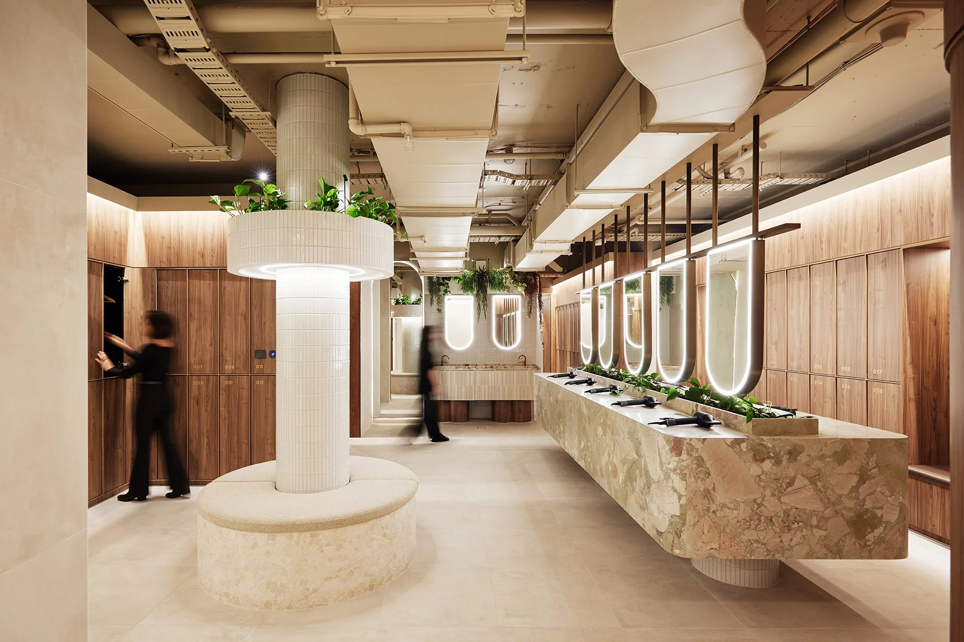
420 GEORGE ST END OF TRIP / COMMERCIAL FIT-OUT

A practical partner for complex building work.
We align scope, cost and programme from the outset, combining disciplined planning with hands-on delivery. Our capabilities support commercial and residential clients through preconstruction, procurement, site delivery and close-out.
Commercial construction  Workplace, hospitality, fit-out and refurbishment projects. |  | Residential construction  New homes, alterations, additions and bespoke residential work. |  | Preconstruction & estimating  Scope review, cost planning, tender strategy and trade package analysis.
Commercial management  Contracts, procurement, cost control, progress claims and reporting. |  | Construction management  Site leadership, programme coordination, trade management and quality. |  | Design & build support  Buildability input and coordination from design development to handover.

PAST PROJECTS

Experience in every detail.
Selected experience of the Palmyra Projects team across hospitality, workplace amenities and residential construction.
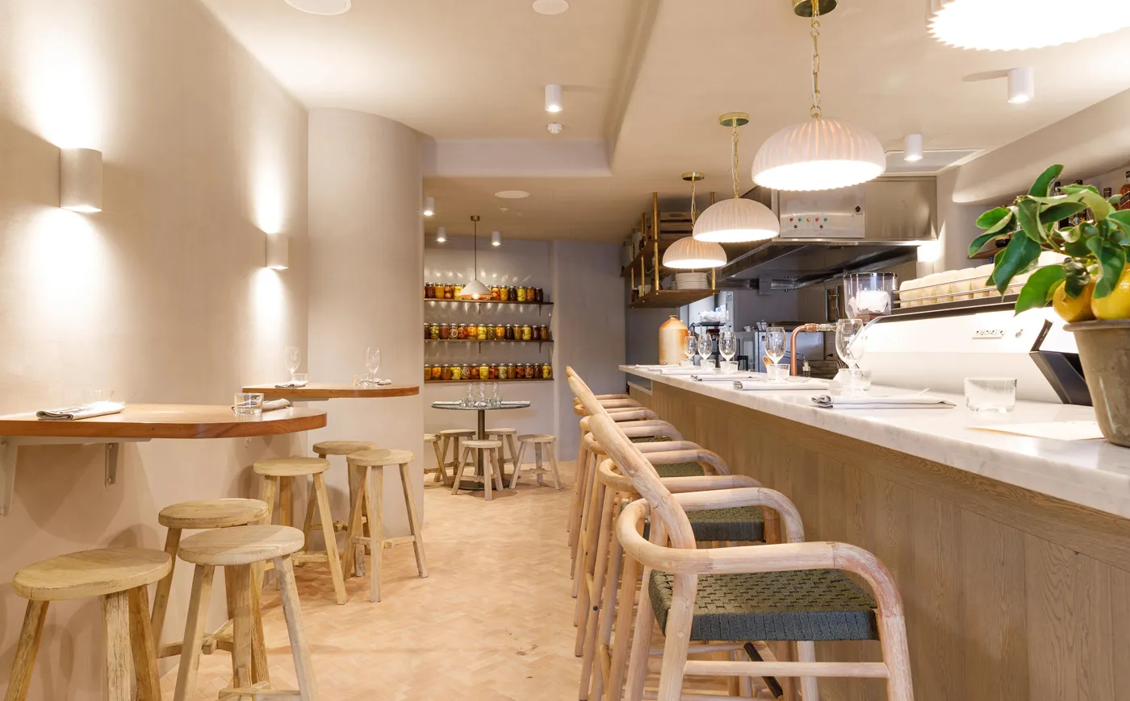 |  | HOSPITALITY / DOUBLE BAY, NSW  Roxy’s Café, Double Bay  A warm café environment shaped by timber seating, neutral textures and coordinated detailing. Joinery and finishes create a welcoming setting for customers.  SCOPE Joinery and interior finishes.

COMMERCIAL / SYDNEY, NSW

420 George St End of Trip
Refined workplace amenities combine integrated lockers, timber joinery and durable finishes. The fit-out balances everyday function with a polished tenant experience.
SCOPE Amenities fit-out, joinery, lockers, seating and finishes.

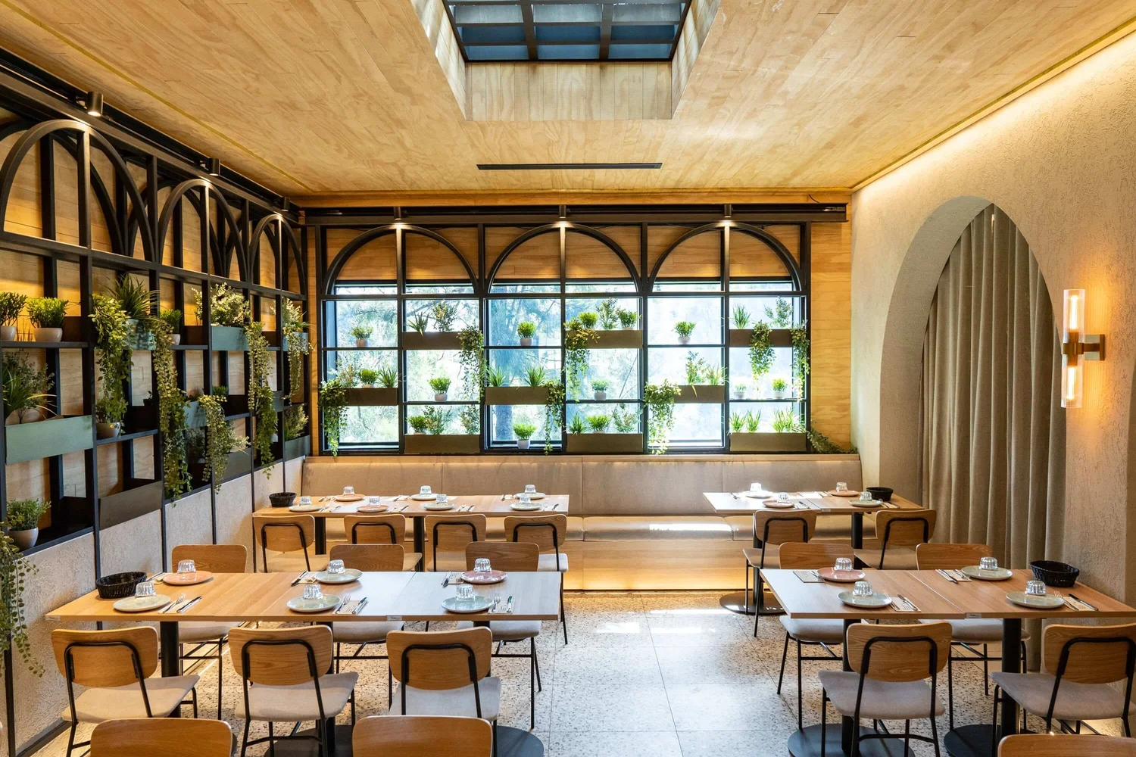 |  | HOSPITALITY / KAREELA, NSW  Jbeil Cuisine, Kareela  Arched detailing, layered lighting and a warm material palette give the restaurant its distinctive character. Joinery and front-of-house finishes bring the dining environment together.  SCOPE Dining fit-out, joinery and front-of-house finishes.

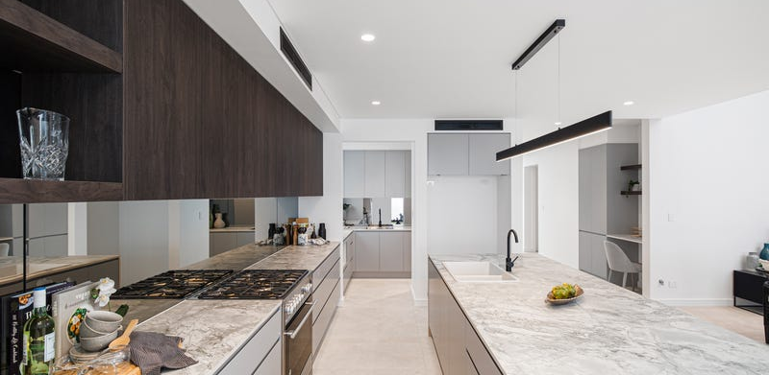 |  | RESIDENTIAL / PANANIA, NSW  Tower St, Panania  Delivered as a design and construct project, this contemporary residence brings together craftsmanship, light and liveability. Architectural detailing connects interior finishes with the exterior and outdoor entertaining spaces.  SCOPE Design and construct, bathroom finishes and external entertaining areas.

PEOPLE & DELIVERY

Three disciplines.
One coordinated team.
Construction execution, estimating clarity and commercial control work together to support informed decisions and accountable delivery.
Hussein Farache  CONSTRUCTION MANAGER  Hussein leads construction planning, site execution and trade coordination from commencement through to handover. His focus is the quality of delivery: aligning site activity with the programme, coordinating subcontractors and managing the practical details that bring the project together. |  | Tarek Farache  LEAD ESTIMATOR  Tarek leads estimating, tender strategy and trade package analysis. He brings clarity to scope and cost before construction starts, supporting procurement decisions, identifying value opportunities and helping the team understand the commercial implications of the proposed work. |  | Kamahl Farache  COMMERCIAL MANAGER  Kamahl leads contracts, procurement and commercial reporting. He connects cost control with programme and project obligations, supporting clear subcontract packages, consistent administration and informed decisions throughout the delivery process.

HOW WE DELIVER

A clear path from brief to handover.
01  Define  Scope, constraints, budget, programme and key risks. | 02  Plan  Estimating, procurement, methodology and sequencing. | 03  Build  Site operations, trade coordination, quality and reporting. | 04  Deliver  Close-out, defects, commissioning and handover.

Let’s talk about your next project.
For tender opportunities, project enquiries or an introductory meeting:
info@palmyraprojects.com.au

